Lazer 8W SMD Amp

This little amplifier circuit was designed around the late 90’s, I had made it for release as a “basic amplifier learning kit” in SMD. The circuit is based on the well renowned blameless circuit by Douglas Self.
At the time, many of the SMD parts were expensive to buy so many did not pursue in building them.

I used them in a few commercial applications, gaming machines, computer speakers, etc.
They had worked very well, and then in 2014, I decided to update it to the V3 Model.
The V3 has the inclusion of the LED and the trim pot to be able to adjust any “offset” voltages in the output.

Although the cost of these parts generally exceeds that of a single IC, this discrete solution can be made up easily enough, work very well and still be done on a tight budget,

To this day, the circuit is still surprisingly good. It is low in distortion, it’s built with SMD components that are now available “off the shelf”, and it sounds great.

It uses the popular transistors, BC550 /BC560, Low noise types, which are now getting difficult to find, the 2N5401/ 2N5551, and the stable high gain TIP31/32 series, in their SMD versions.

For the preamp section, the input stage is based on a conventional long-tailed pair, called an LTP.
A constant current source, formed by Q11, and the use of a current mirror stage by Q3 & Q4.
This set up has an improved gain.
Over the years, variations in parts, showed around a +/- 12mv in the outputs’ offset voltage, although this is normal in most amplifiers. I wanted to reduce it, so when I revised it, I added the 100 Ohm Trim pot in the LTP. This allows you to trim the offset voltage down to +/- 1mv.

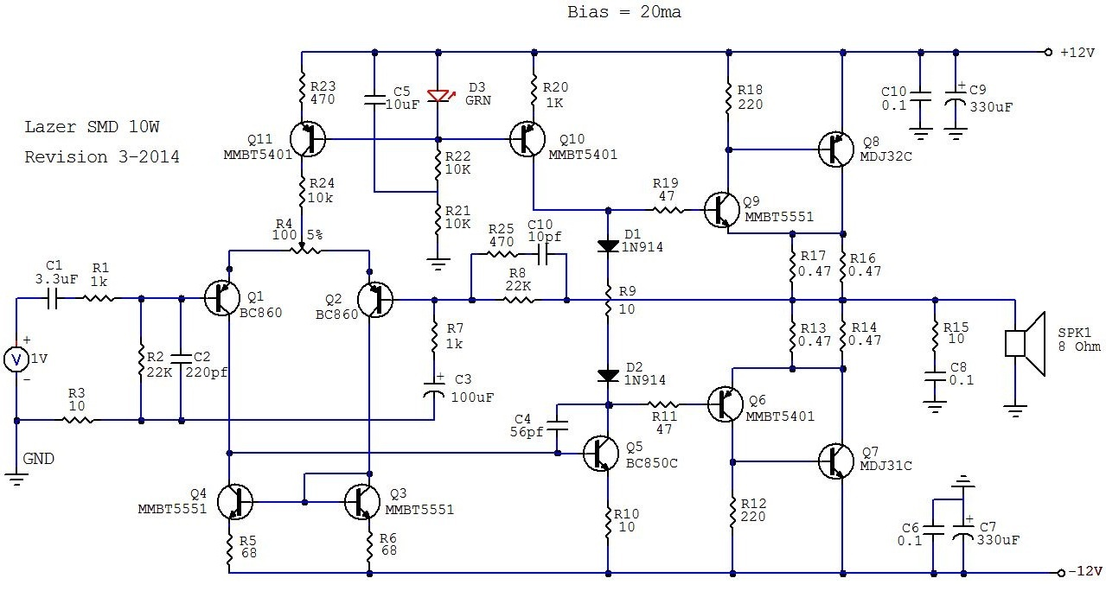
The Vas Stage consists of Q5 while the Miller Capacitor is 56pf, using a low value capacitor here is trial and error. While it increases the slew rate it opens the output stages to oscillation. I didn’t find this problem at 56pf or higher. If any oscillation is seen in your build you will need to increase this value to 100pF. Q10 feed the bias chain consisting of the 2 x Diodes and the 10Ohm resistor. If your supply voltage is different this may need to be adjusted to maintain 20-30ma when the amp is running.
The output stage consists of a Sziklai type which is well known for its easy layout, low bias control and provides a wider band with.
The 2 x 47Ohm resistors help to reduce any chances of oscillations in this type of output stage.

Assembly:

This PCB is double sided, It generally does not require as much heat for the small parts but does to solder the larger Transistor pads. You will need a good hot soldering iron. It will need to be 48W or more.
Wipe it often on a wet sponge or cloth, to keep it clean, and then apply a little solder to the tip, to give it a wet look. This is called 'tinning' and will help to protect the tip. It also enables you to make good connections. When the solder looks dirty on the tip, it needs cleaning.
Use thin resin-core solder and good quality flux gel.

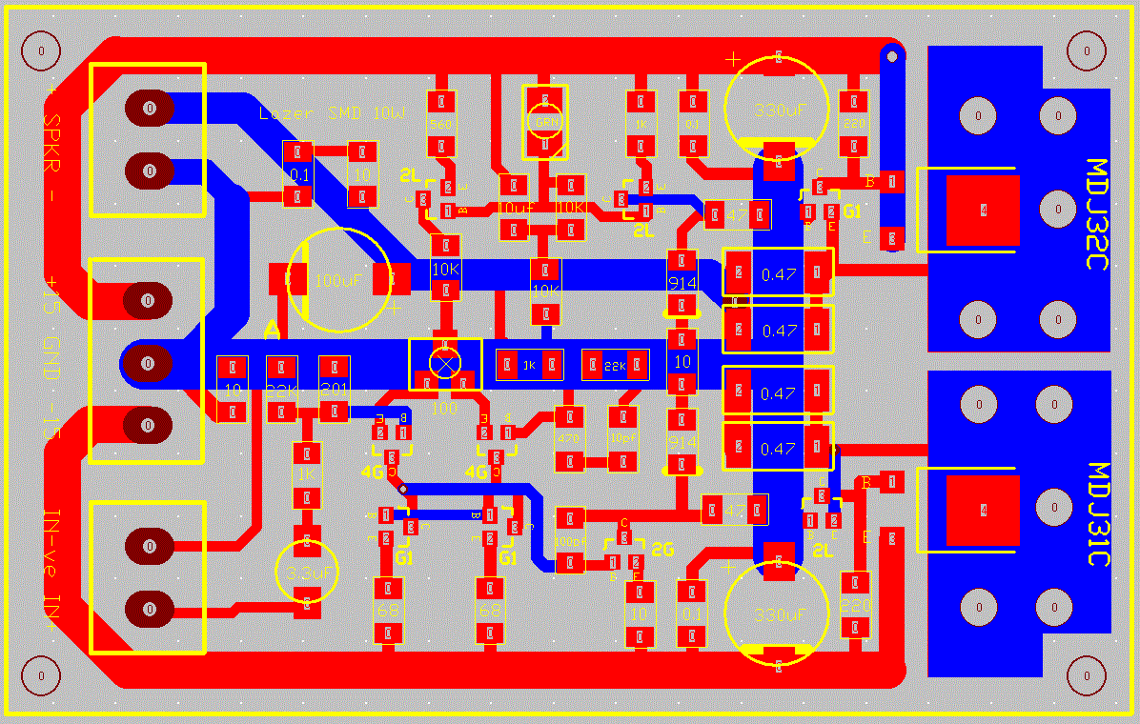
Firstly, Inspect the PCB for any shorts or cracks that may have been missed by the PCB testing machines..
Place the general components on a clean surface area around the PCB, but not the transistors or the smaller SMD caps, and familiarise yourself with all of them. The transistors should be left in their pkg until required. They are difficult to see the part numbers and you don’t want to mix them up!
Install the resistors and diodes first, check the component values with your DMM to be sure you have not mixed them up, very easy to do with SMD.

Then,

Place a small amount of solder one side of the pads for the component you are fitting, only use a small amount of solder, 2mm length x 0.5 grade, add a very small smear of SMD flux paste, move the part into position and resolder it until the connections “fuse” together with the solder. Solder one pad at a time, Do that for all the resistors first and the diodes.
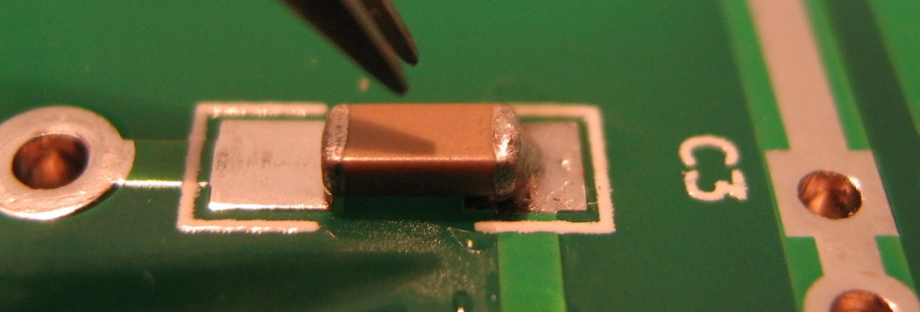

Then check with your multimeter that all these parts measure correctly as they will be difficult to remove later. Ensure the 2 x diodes are installed, in place, the correct way around.
Turn the PCB around and solder the other sides with the 0.5mm solder provided.
Then install the transistors, use the same process and a little flux to help soldering.
Note the orientation and the part numbers of these transistors and their position.
Do not mix them up.
Check the transistor codes are correct before placing and soldering them. It’s too hard to remove after!

Then fit the 100 Ohm Trim Pot, use some solder paste as this is difficult to solder. Solder one pad then spin the PCB around, check the alignment is good and solder the other two pads
Next,
Fit the two main output transistors, MDJ31C and MDJ32C, onto the PCB. This will require a very small dab of solder in the centre of the main PCB pads and then add a touch of flux to the pads. With good tweezers, move the transistor over the pad and carefully align it, Check you have not mixed up these two transistors.
Place you’re soldering between the transistors tab edge and the pad, until both get hot enough and “fuse” together, then remove the soldering iron. Do not take too much time doing this (3-4 seconds) or you will damage the transistor. Turn the PCB around and solder the other two legs.

Then, Install the bigger capacitors.

Note the 2 x 330uF-25V and the 100uF-35V capacitor’s polarity. The Line on SMD caps is the negative side
The input capacitor, 3.3-25V is a bipolar type, which means it can be installed either way around.
As the output is fed to the speaker at the front of the PCB, this circuit employs a “Zobel Network”.
These circuits are added to ensure stability when driving reactive loads.
They typically employ a 4.7 Ω to 10 Ω resistor and 100nF capacitor to earth.
The Completed PCB: shown is one of the many test samples

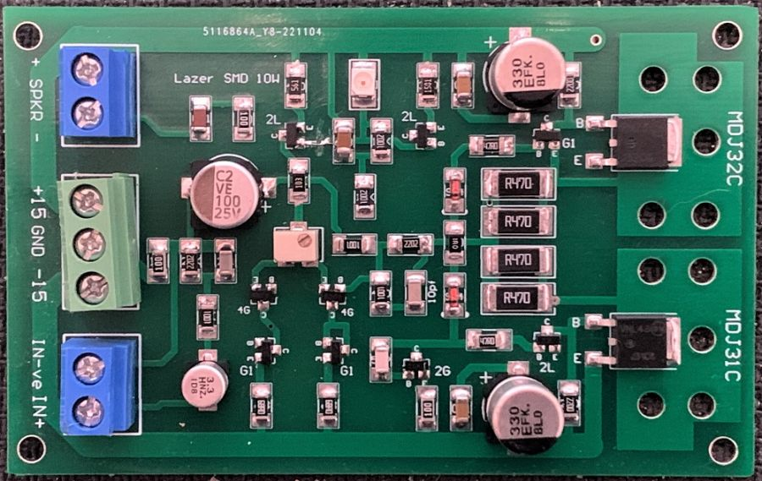
After assembling all the components to the PCB, sit back, inspect your board for any parts that are not soldered and/or fused well and check that all components are correctly installed and aligned.
Clean the PCB with Fluxclene or similar then blow dry it all out with a hair dryer.

Testing

Do not connect anything to the input or the speaker terminals as yet.
Connect the centre pin terminal, marked 0v, to the 0V of the power supply,
Then connect the +12V of the power supply, to the power amplifiers terminal, if you have a “current meter”, now is the time to use it, place it in line from the +12v of the power supply, this will help to measure the current into the amp, and hope to safe guard the amp parts should there be an issue with your wiring or if you have incorrectly installed components, Then connect the -12V to the amplifiers -Ve power terminal.
Connect your multi-meter into the speaker terminals, set it to read voltage.
Set the trim-pot around the middle of its turns, or around 50 Ohms.
Power up and observe.
If the reading from the multimeter is above 200mv or the current meter swings past 100ma, then there is a problem, turn off the supply and check the components are in the correct positions,

Check the transistors installed are correct type and in the “right location”.
Check that you have not mixed up the positions of the MDJ31 & 32 transistors.
Check there are no bridged solder connections under the PCB

If all is well, the amp should power up ok and then measure the Bias is around 20-25ma, +/- 5ma.
This is set by the 1K Resistor, to the right of the green LED, R20-1K.
Then measure the Output Voltage at the speaker terminals, it should be no more than +/- 20mv.
Adjust the trim-pot until you get around +2mV to – 2 mV….. it does not need to be exact.
Up to +/- 35mv is normal in many amplifiers.
Leave the amp on for a while and recheck the Offset Voltage and the bias drawn.
If all is ok then connect your speaker and line inputs and away you go, Enjoy.

If you run the amplifier hard for long periods then I suggest you mount it to a Heatsink, Use a good quality 2mm thick thermal pad. Do not overtighten the 4 x Screw when installing and use a touch of nail polish on them to keep them screwed in, so they don’t come loose.

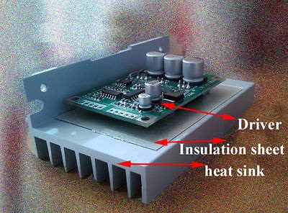

The BOM below is provided with prices in AUD and based on the use of “decent parts” and “average street prices”.

These prices are given in general terms but can vary a lot in shopping around.

BOM V3-2014 Updates
 | Part | Does what? | Cost
R1 | 1K Ohms-1206 | Input Limit | $ 0.03
R2 | 22K Ohms-1206 | Input Shunt | $ 0.03
R3 | 6.8-10 Ohms-1206 | Ground Lift | $ 0.03
R4 | 100 Ohms-trim | Offset balance Trimmer | $ 0.05
R5 & R6 | 68 Ohms-1206 | LTP Balance | $ 0.10
R7 | 1K Ohms-1206 | Feedback Set | $ 0.05
R8 | 22K Ohms-1206 | Global Feedback | $ 0.05
R9 | 10 Ohms-1206 | Bias trim | $ 0.05
R10 | 10 Ohms-1206 | Vas Balance | $ 0.05
R11 & R19 | 47 Ohms-1206 | Pre Drivers Damp | $ 0.10
R12 & R18 | 220 Ohms-1206 | Pre Drivers Set | $ 0.10
R13, 14, 16, 17 | 0.47 Ohms-2510 | Degeneration, Output | $ 1.00
R15 | 10 Ohms-1206 | Zobel Network | $ 0.05
R20 | 560 Ohms-1206 | Bias Set | $ 0.10
R21 & R22 | 10K Ohms -1206 | Current Feed Back | $ 0.05
R23 & R25* | 470 Ohms -1206 | LTP Current set & feedback (opt) | $ 0.05
R24 | 10K Ohms-1206 | LTP Current Limit | $ 0.05
C1 | 3.3μF-Bipolar 5mm | Input Signal | $ 0.30
C2 | 220pf 1206 SMD | HF Input, Roll off | $ 0.05
C3 | 100μF-25V- 5mm SMD | DC blocking Feedback | $ 0.25
C4 | 56pf 1206 SMD | Stability+HF | $ 0.25
C5 | 10μF-50V 1206 SMD | Bootstrap Cap | $ 0.15
C6 & C10 | 0.1μF-50V 1206 | Noise & Decoupling Shunt | $ 1.00
C7 & C9 | 330μF-25V- 5mm | Line Decoupling Capacitors | $ 0.80
C8 | 0.1μF-50V 1206 | Zobel Shunt | $ 0.05
C11* | 10pf 1206 SMD | Option HF Gain roll off (opt) | $ 0.05
LD1 | 3528-GREEN | Green LED V drop | $ 0.30
D1 & D1 | 1N914/4148 Diodes | Bias Control | $ 0.08
Q1 & Q2 | BC860C-sot23-4G | LTP | $ 0.50
Q3 & Q4 | MMBT5551-sot23-G1 | Current Mirror Transistors | $ 0.50
Q5 | BC850C-sot23-2G | VAS Driver Transistor | $ 0.30
Q6 | MMBT5401-sot23-2L | Pre-Driver Transistor | $ 0.30
Q7 | MDJ31C-NPN-Dpak | Driver Transistor | $ 1.00
Q8 | MDJ32C-PNP-Dpak | Driver Transistor | $ 1.00
Q9 | MMBT5551-sot23-G1 | Pre-Driver Transistor | $ 0.30
Q10 | MMBT5401-sot23-2L | Current Transistor | $ 0.30
Q11 | MMBT5401-sot23-2L | Current Transistor | $ 0.30
Con 1 | 2P 5.08mm 2 Pin PCB | Screw Terminal Block Connector | $ 0.30
Con 2 | 3P 5.08mm 2 Pin PCB | Screw Terminal Block Connector | $ 0.50
Con 3 | 2P 5.08mm 2 Pin PCB | Screw Terminal Block Connector | $ 0.30
PCB | Lazer 8W SMD Amp | 8W-V3 SMD PCB | $ 3.80

The components shown above are New Parts removed from our production.
We use On-Semi, TI and Diotec Semi in our semiconductor range. All “National Semi” parts are now made by “TI” Texas Instruments.
Texas Instruments retains manufacturing of many factories and products under their original brand and brand names, we have never had any issues with their products, and they have always worked perfectly.
Updated 2025

