Lazer Dual Linear Supply PS30VA
These Linear IC Supplies were designed a long time ago, and over the ages, they have been true winners! Especially for, National Semiconductor, for DIY’s like myself and millions of others.
When I made the original versions of the LM7812 /LM7912 series and the PCB in school (around the 80’s),
It was on a single sided board and was very impressed with its performance, they worked very well.

During this time, these IC’s became the basic building blocks of most power supplies around the world, and they continue to this day. I used these IC’s in many projects and in commercial applications.
They are very reliable, but they are not the most efficient,

Since then, I have spent many years in developing switch mode power supplies (SMPS) for LED lighting and LED strip. The SMPS supplies are great for their small size, high power, low costs and good efficiency, but they are terrible for use in clean sounding audio amplifiers, AM radios, many other RF circuits and they generate RF Noise. Despite what others say, there will always be some form residual noise emission from these types of supplies. We might make them to pass “standards” but the noise figurers below 30 MHz are still present!

For a simple, reliable, clean source of DC power, using discrete components that can be made up very easily, you simply cannot go past the LMXXX series of IC’s. The LT series is available but you need to add 15.00 ea.

After seeing a lot of rubbish on the web, poor quality circuits, under rated parts and worse, fake copied parts, as well as most of these kits sold with No heatsinks, I decided to bring back my old linear supply designs and build them on newer boards, with double sided 2oz copper tracks and with the parts I have.
These are for sale in kit form, for those who want a decent Regulated Power Supply that’s very easy to build. If you have parts lying around then we can supply the PCB only.
This Project requires the connections made to the “mains”. Therefore it is imperative to check all wiring connections made, are done in a safe manner and in accordance to the rules. The most important thing is to understand, learn, and respect the high voltages and to build this with the maximum safety of yourself and others.

The Full Circuit: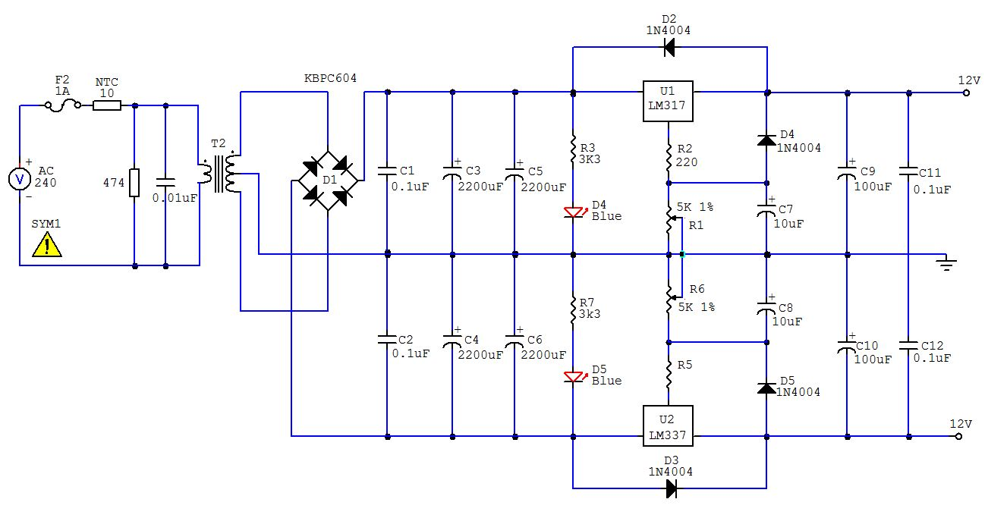

This basic circuit diagram shows the full power supply, as made by us and used in previous productions, it differs a little from the many others on the web in that it has a few important details that many have left out.

I have made this project with parts I had lying around from production runs from many of the SMPS that are produced here and overseas.
So I know the quality of the components, capacitors and other parts used here is excellent.

On the mains side, mains transformers, by their nature, can cope a lot better with the modern-day surges and spikes than many switch mode power supplies.
In this project, I have added some newer features to the input side to “modernise” it.
It has an NTC which helps reduce the “inrush” current through the transformer and an MOV to help contain or limit voltage spikes.
I have also added Ferrite Beads onto the Bridge Diodes Legs to help reduce unwanted EMI noise.

How it works:

When a 240/12V ac transformer is converted to DC, with a bridge rectifier and capacitors, it basically gives you 12Vac x 1.41 = 16.92Vdc (peak). Then take away around 1.2V for the loss through the Bridge’s diodes and there is around 15.7V. These linear regulators require 2.75-3V above the Operating Voltage that you need.
If you require 12V DC then using a 18Vac or higher transformer would simply be waisted as heat in the IC…...
So, for a 12V Output, I would get a good 13-15VAC transformer.

The inclusion of a “Fuse” is mandatory, to protect you, the product and for safety should something go wrong.

The addition of the 10 Ohm NTC is there to slow down the “Inrush Current” when switching the supply to on, this is a great product and I use it everywhere, especially now that the prices for these have dropped.

The MOV (Metal Oxide Varistor) is there to stop high voltage spikes from entering the circuit. This is more of a modern-day issue of line surges and transients passing through the mains.

C0, Dampens the inductive spikes that occur when the power switch is turned on/off.
The capacitors, C1 & C2, are to filter HF noise in audio systems to help reduce unwanted noise.

For working out the filtering capacitors, I use a “general rule of thumb” of 2,000uF per 1 amp required.
Here I have 2 x 2200uF for each side, so 2A is Guaranteed !
Diodes must be used for their intended purposes and within their ratings.

I must stress, the common 1N4001 series are a great product but they are not good enough to run more than their 1A rating for making a “bridge” when the regulators IC’s are capable of 2.2-2.5A in a dead short output. Here I have used a 6A bridge,, and I added some ferrite Beads to reduce unwanted noise in the output.

The LM317/337 regulators were chosen to the LM78XX Series as they are superior in almost every specification. These LM317/LM337’s series have a noise figure of < 0.12 mV, well below the Power Supply Rejection Ratio (PSRR) of many operational amplifiers. So, they are well suited for amplifier use.
If, you intend to build this for and amplifier then you must keep the voltage of the transformer 3-4V higher than the Voltage Output required, to keep it efficient.

Firstly Inspect the PCB for any shorts or cracks that may have been missed by the test machines.
As this PCB is double sided, it will require more heat on the pads and to solder the components.
You will need a good hot soldering iron, it needs to be 40-50W or more.
Wipe it often on a wet sponge or cloth, to keep it clean, then apply a little solder to the tip, to give it a wet look. This is called 'tinning' and will protect the tip, and this will help you to make good connections. When soldering looks dirty on the tip, it needs re-cleaning. Use thin resin-core solder. You can use soldering flux or gel, but don’t use too much as then you will need extra time and care to clean it all off….

Firstly, we will fit the SMD parts, there are two resistors and two LED’s. Solder one side of the SMD pads Then, align one side of the part to the pad and solder so they “fuse” together. You can use a touch of flux here. Turn the board around and solder the other sides of the resistors and the LED’s to their pads.
Note, the SMD LED’s orientation is correct.

Then fit the diodes, but before fitting these parts, bend the legs at 90 degrees at around 3mm from their case.
Then fit the bridge rectifier. This part also has 4 x Ferret beads on its legs. Make sure the bridge rectifier is installed the correct way around and then solder.

Next, install the 2 x 5K trim pots. Another alternative is to use a “dual gang volume pot” if the product is to be used as a general power supply.

Then, install the capacitors 10uF, 100uF, 0.1uF, 0.01uF and the 4 x 2200uF capacitors.

Caution, double check the polarity of the capacitors is correct. Fit up all the other parts and solder as you go.

The LM317T & the LM337T will need a small dab of “Decent Thermal Paste” on the back. Then screw them down with the M3 Screws provided onto the heatsink. Insert the Heatsink and the IC’s into place and solder.

Fit all the other parts with the transformer as the last part, and solder. Check that your soldering Iron has had enough heat and that the solder has flowed smoothly into each pad/join.

The PCB Overlay:

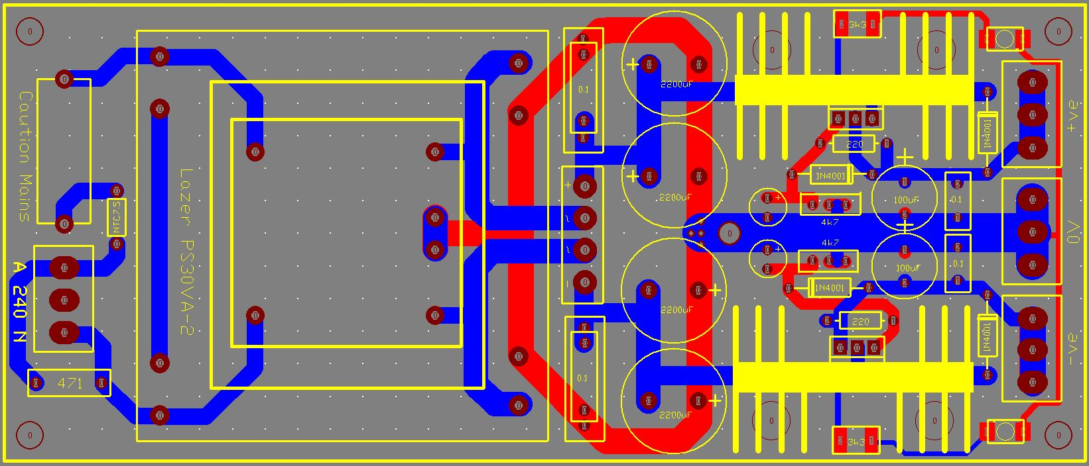

Testing: You must take all precautions from here on.

Double check all you parts are correctly fitted, orientated and there are NO solder bridges anywhere on the PCB or the parts fitted. Do not connect any load yet,

Please take care when doing this. On a perfectly clean bench space, place your completed kit.
Double check there are no parts incorrectly fitted, No solder joins or bridges under the PCB and/ or any shorted tracks.
If you have an old 50w light bulb, it would be good to use it in series with the active line of the power lead. Use a switched power board if possible with an inbuilt fuse, if you have one.
Sit correctly, wear appropriate shoes and isolate yourself from touching any part of the bench or floor.

Connect a 240V AC power lead to the AC input terminals of the supply.
Generally the Active is Brown and the Neutral is Blue. Do not connect any load yet.

Connect your multimeter across the Output Terminals, Set the Trim pots to minimum (rotate anticlockwise).
Power up and observe.
The LED’s on the front should light up and then give you a reading on your meter, this should be around
2-3 Volts.
If it is above 3V or at 0, then there is a problem, quickly turn off the supply and check you’re soldering for shorts and/or all components are in the correct positions, check that the diodes are fitted in the correct way around….

There is a M3 Hole made at the base of the main filtering capacitors in the 0V line, it is there for connection to the chassis, if required, by a M3 Bolt, or you can run your – ve wires from the speakers to this point if the supply is used in an amplifier. This is done to help reduce the chances of “Hum”.

I have provided pricing in this BOM, but it will vary from supplier to supplier, it is intended to give you a rough guide to current market prices (2014).

BOM : LAZER-PS30
Part | Specification | QTY | Does what? | ~ Cost
R1 & R2 | 2K7 - 3K3 Ohms-0.6 W 1% | 2 | Power for LED | $ 0.03
R3 & R4 | 220 Ohms – 0.6W 1% | 1 | Max I set for LM350TG | $ 0.03
C1 & C2 | 0.1μF-250V- 10mm | 2 | Noise & Decoupling | $ 1.60
C3,4,5,6 | 2200µF 35V-7.5mm | 4 | Filtering Capacitors | $ 8.00
C7 & C8 | 10µF 35V | 2 | Output Stability | $ 0.20
C9 & C10 | 100μF-35V- 8mm | 2 | DC Line Decoupling | $ 0.30
C11 & C12 | 0.1µf 100V--10mm | 2 | DC Line Decoupling | $ 1.00
D2,D3,D4,D5 | UN4001 Diodes | 4 | Protection Diodes | $ 0.20
BR1 | KBU-608 6A 800V | 1 | Bridge Rectifier | $ 2.00
LED | Lazer – PLCC2-B | 2 | 1210 SMD Blue LED | $ 0.20
VR1 | 5K Multi turn Trimmer | 2 | Trimmer sets voltage out | $ 1.00
IC1 | TI-LM317T 1.5A IC REG |  | POS Linear Regulator IC | $ 2.50
IC2 | TI-LM337T 1.5A IC REG | 1 | NEG Linear Regulator IC | $ 2.50
MOV | Metal Oxide Varistor | 1 | 471K 10mm Varistor | $ 1.00
Con 1,2,3 | Screw Terminal Block | 1 | Screw Terminal Block | $ 2.00
NTC | NTC7.5 or 10 | 1 | NTC7.5 or NTC10 Ohm | $ 0.50
HTSK L | 36mm x 22mm Heatsinks | 2 | IC’s Heatsink | $ 3.00
M3 x 8 | M3 x 8 Flat Head screw | 2 | M3 x 4mm Philips Flat head S | $ 0.02
TR1 | M4624A 240-12+12V TR | 1 | Mains Toroidal Transformer | $ 38.00
LZR-PCB-PS30 | Lazer Power Supply PCB | 1 | LM317/LM337-PS-PCB | $ 7.50

Components supplied in the kit, from us, is made up of a combination of Brand-New Genuine Components and Removed Parts, these “Removed Parts” are highlighted in Violet above. They are new parts that were removed from products that never reached the market place and/or sold or used.
This helps to keep the costs down, well below market value. These “Removed Parts” are included when you purchase the kit from us, they also have a full 12 months warranty.

I have a simple policy, I do not believe we should throw away NEW parts into land fill, so, we spend a lot of personal time removing them carefully, and checking them to be 100%.

Notes: Application notes from National /TI:
For LM150/317/337 Usually R1 = 240Ω
and
R1 = 120Ωfor LM350 Series.

Revision 1.3. PCB + Spelling

