Lazer Simple Amp Supply PS-100
The basic audio power supply has been around for many years, this one is easy to build and use, it’s reliable and it has always worked well in audio amplifiers of up to 100W or 50+50W.
I made some for my older LM3875 Projects in the 90’s and they worked very well, but routing the wires and GND’s were a problem on those amps … as well as the turn on thump, another project covers that issue.

Why did it work better than regulated supplies?
Small power amplifiers, around 5-20Watts, can run very well on a “Regulated Power supply” as they don’t draw enough power that the regulators cannot supply, but bigger power amplifiers can suck “many amps” of current in a split second when deep and punchy bass notes are pushed through them. This requires “the capacity of stored energy” and these types of power supplies, (next to a Battery) still rule.

The Good side.
These power supplies are simple and solid. They use a low parts count and contain a lot of µF capacitors. The stored energy and capacity of these capacitors give the amplifier a solid boost of energy (current drawn) at lower frequencies. That is why you see so many amplifiers with “Big Caps” Inside.

The Downside.
They are bulky and expensive. It is all about the instantaneous power, there is not a constant draw. Like say LED strip or LED lights, So for music played in an amplifier, it’s perfect. These supplies being unregulated simply require the amplifier to have a higher power supply rejection ratio (PSRR) against the ripple of the supply’s output. To help reduce this effect, there are 2 x 0.005 Ohm resistors built into the PCB.

I made many of these over the years and they were built on single sided boards. The big types of capacitors (New) at that time were very expensive.
There used to be many electronic shops supplying big capacitors from computer gear but they have now vanished over time.
I got a 300VA Toroidal Transformer, A 25A bridge rectifier, a pair of amplifier PCB’s and Aluminium case. Threw them all together to make a very simple and decent 100w amp. So it was “Back the Future” on this model and the PS-200.

I have spent many years in developing switch mode power supplies (SMPS) for LED lighting and LED strip. The SMPS supplies are great for their small size, high power, low costs and good efficiency, but they are Not good for use in clean sounding audio amplifiers, near AM radios, many other RF circuits, and they do generate some RF Noise. Despite what others say, there will always be some form residual noise emission from these types of supplies. We might make them to pass “standards”, but the noise figurers below and above 30 MHz are still present!

So, after seeing a lot of rubbish on the web, poor quality products, fake copied parts, especially the Capacitors, Small Tracks on cheap PCB”S, I decided to bring back this trusty old supply design and build it on a double sided board with parts I have.
Why should you be interested in building a power supply if you already have an amplifier? Most power supplies in amplifiers are built to a price budget, especially the cheaper amps, this is where the money, is saved, in production.

If you have parts lying around then we can supply the PCB only.
I use these in the 38W LM3886 Amps and the 60W Camp amps.

This circuit diagram shows part of the power supply, as used in previous productions; it differs a little from the many others on the web in that it has a few important details that many have left out.

A The PCB’s connectors NEED to be 15A+ rated for good connections.
B The Bridge rectifier is not mounted on the PCB as it is a 25A panel mount type and the heat generated,
needs to be heatsinked to a chassis to perform reliably.
C Many of the power supplies on the internet lack good and generous ratings of the parts used.

Example: A group of 4 x 1A Diodes made into a bridge and driven at 1A +. The 1A, is the diodes Maximum rating.
These diodes should not be expected to run constantly past 50% of that value.
I have seen many failed, and many of the “too small” Bridge Diodes have done the same.
You must learn and understand this.

Be careful what you buy, there is no easy or cheaper saving to be made by buying cheap and /or fake parts!

The Mains Circuit:

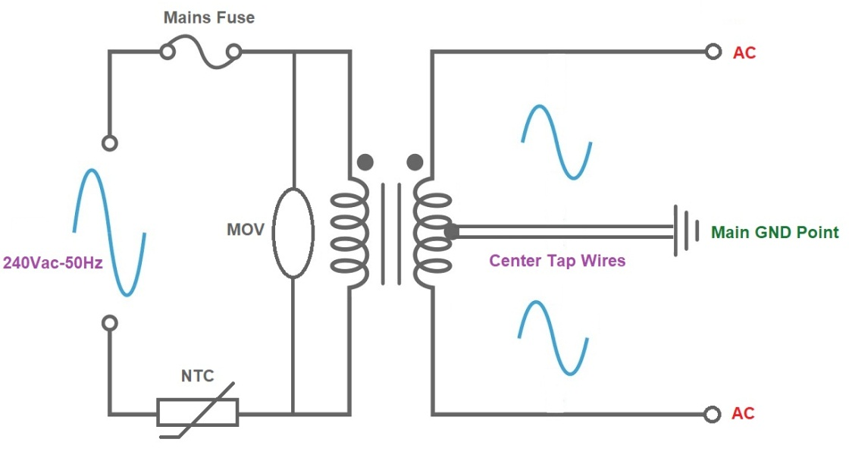

How it works:
Toroidal Mains Transformers, by their nature, are fantastic and can cope a lot better with surges and spikes than many switch mode power supplies. Which is why, we still use them, for long term stability and reliability.
As the transformer is connected to the mains (240V) you must be very careful here.

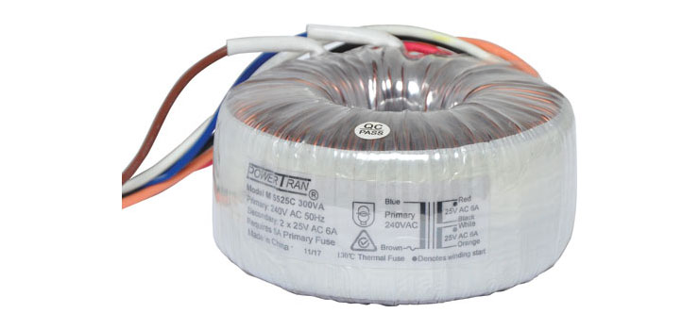
On the mains input side, the inclusion of a “Fuse” is mandatory, to protect the product, to protect you, and for safety of all else, should something go wrong.
From the example above, the Active (Brown) wire from the mains lead runs to the brown wire of the transformer’s input wire via a fuse. The value of the fuse will depend on the transformer you use. The Neutral (Blue) from the mains lead will generally run to the other side.
The addition of the 10 Ohm NTC (value for up to 120VA) is there to slow down the “Inrush Current” when switching the mains supply to on. These NTC’s are made for Inrush Current Protection, they are not the Thermal Sensing types.This is a great product and I use it everywhere, especially now that the prices for these have dropped.
The MOV (Metal Oxide Varistor) is there to reduce high voltage spikes from entering the circuit. This part, “Shunts High Voltage spikes” above a value chosen, normally these are around 305-320Vac , A High voltage capacitor, X series type, can also be added across the MOV to help reduce HF noises and slightly increase the transformer efficay by correcting the power factor, when an AC transformer is used in and AC circuit.

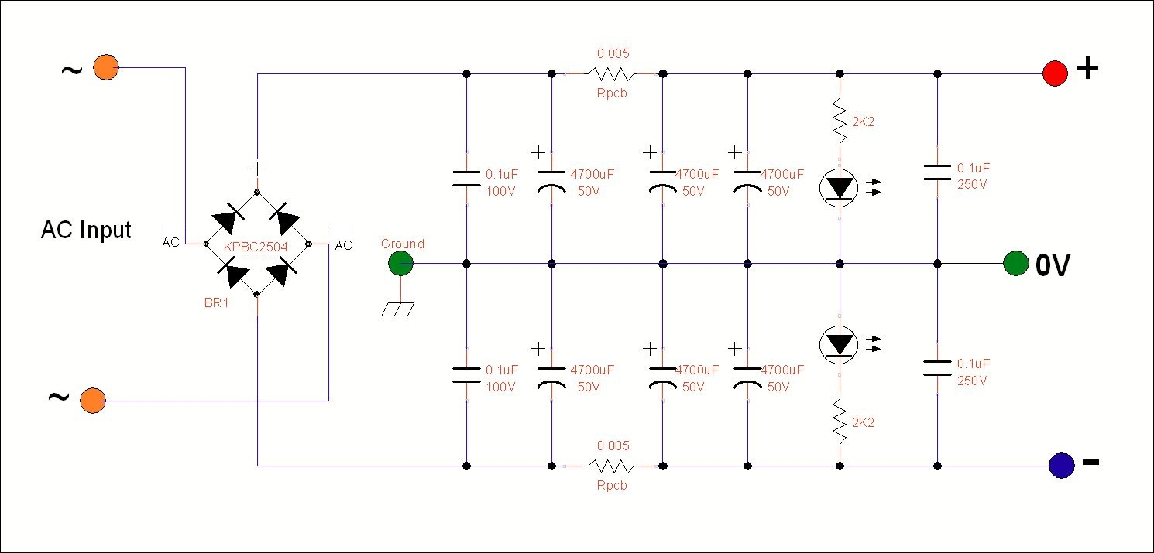 .
The example, as in the photos above and below, is a Toroidal Transformer with 2 x pairs of secondary output leads. The beginning of the first winding and the end of the second winding will go to the AC sides of the Bridge Diode,
While, the other two wires will be joined together, to form the “Centre Tap”, see above example.
These two joined wires will then run to the CT terminal on the PCB.
This PCB has been designed for this application, and all Grounds will come back to this area/point.
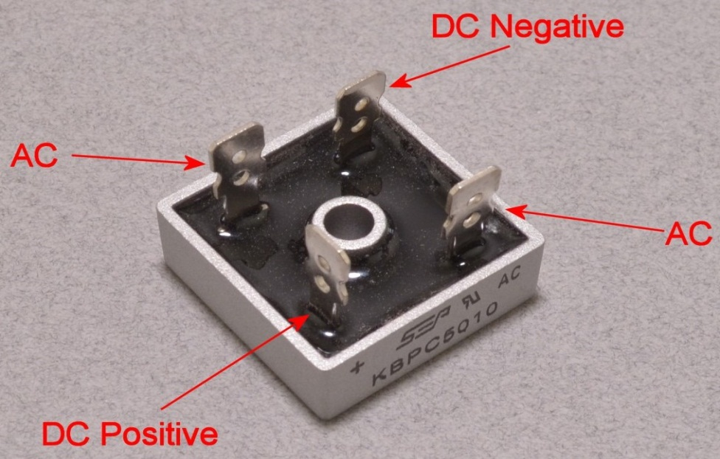

Fit the Bridge Rectifier onto your chassis, usually between the transformer and the Power supplies PCB. Add a smear of thermal paste between the base to the bridge rectifier’s case and the chassis, this will help cooling,
Use a Bolt, 2 x washers, 1 x star washer or a spring washer and then the nut.
Spring washers are great as they stop products from coming loose over time, and star washers ensure good contact for earth wires to the chassis.
Use 3mm grade or 10A minimun rated flexible wire and run the wires in twisted format, this reduces the wires emmision’s of 100Hz hum , keep the wires close between the Tranformer, Bridge rectifier and the power supply PCB.

The DC positive wire will run to the +ve terminal on the PS100 PCB and the DC Negative wire to the –ve side.
The Earth (Green or Green /Yellow) Wire from the mains lead will, make/form, the Earth wire connection to the chassis point, if you use a metal case.

In this supply, I used a Solid Brass Bolt through the chassis and PCB to form a single earth point (called Star Earthing)
Some facts:
What value of capacitor is required to give a full load ripple voltage of less than 5V peak to peak ?
This is a whole other topic on its own!! From Tech days / old school.

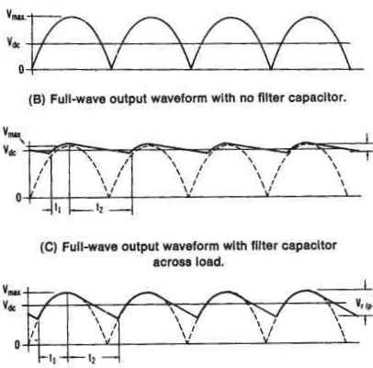

My Equations differ a little from my experiences!! Why? In power suppliers for voltage regulators, I generally use 2,200uF in capacitance values/1A. I use the similar plan for Power Amps.
When you buy capacitors, it’s very rare to find them exactly as quoted on their labels, they usually fall short! So, Keep it simple.
C1 & C2 dampen the inductive spikes that occur when the power switch is turned on/off.
They are also there to help reduce unwanted HF noise.

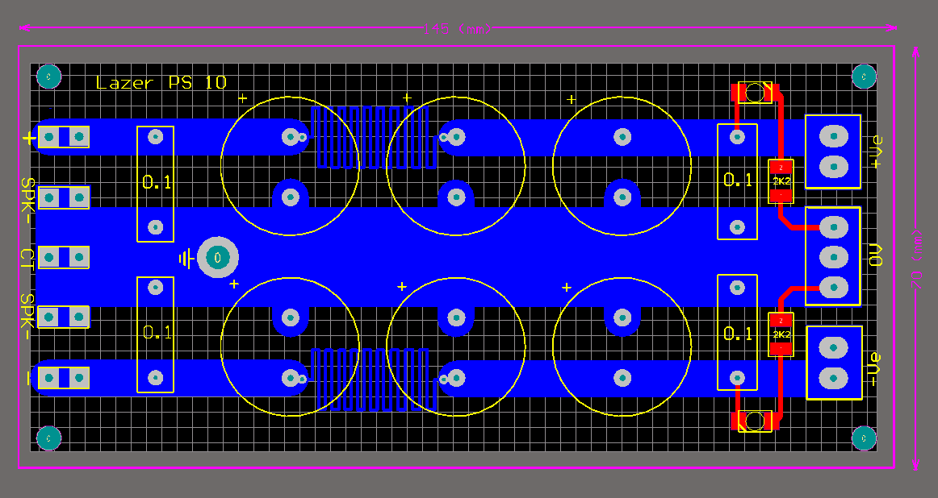
Then there is the first bank of 4700uF Caps to start filtering the 100Hz ripple from the DC side of the bridge rectifier. The current then passes through the low value resistors made in the PCB to the next bank of 4700uF Capacitors.
After these large capacitors there is another pair of smaller 0.1uF capacitors, C9 & C10, on the output, again they are there to help reduce HF signal noises. The ones I supply are rated to > 250V.
There are two Leds to indicate the +ve & -ve DC power is present when using the power supply.
As I have made this project with parts I have from production runs, the PS100 Power Supply uses 6 x 4700uF 50V Capacitors. The main capacitors used here are the Lelon brand. These are good capacitors with a balance of price and quality. I have never seen these fail or lose much of their capacity over time.

The PCB:
This PCB is double sided, it will require more heat on the pads and to solder the components.
You will need a good hot soldering iron, it needs to be 48W or more and preferably adjustable.
Wipe it often on a wet sponge or cloth, to keep it clean, and then apply a little solder to the tip, to give it a wet look. This is called 'tinning' and will protect the tip, and this will help you to make good connections. When soldering looks dirty on the tip, it needs re-cleaning. Use thin resin-core solder. Do not use any grease type solders.

Assembly:

Place the components on a clean area around your PCB and get familiar with them.
Inspect the PCB for any shorts or cracks that may have been missed by the test machines.
Look closely at the SMD LEDS and see that there is a Line or a corner section on the Case, the “corner section” must face towards the negative side.
Solder one side of the SMD parts pad, grab the LED gently and slide it across to the pad and solder.
Then do the same and fit the 2 x 3K3 resistors and solder.
Then, Install the 0.1 (104) Capacitors, and then the 6 x Big Capacitors. Check the polarity of the Electrolytic capacitors is correct and fitted the correct way around. Caution, double check everything

The Completed PCB:
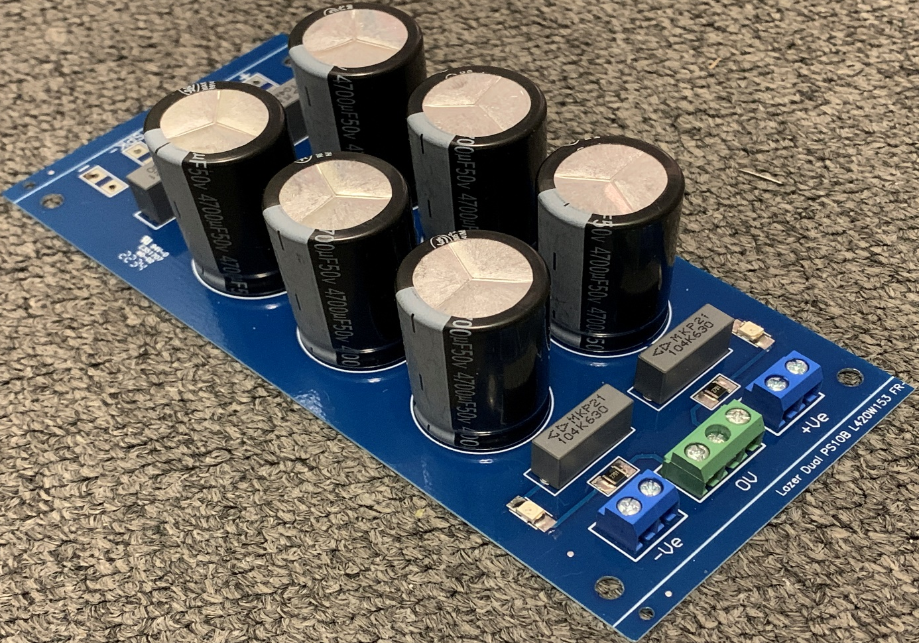
Testing & Notes:
All power supplies must be protected by A fuse and/or an approved circuit breaker, and all mains wiring must be suitably insulated and protected against accidental contact to the specifications and requirements. As this project uses the 240Vac Mains. It is dangerous and can kill. I suggest the completed project should be checked by a Licensed Electrical Person to ensure there are No electrical faults which maybe encountered.

Connect your multimeter across the Output Terminals, Power up and observe.
If the fuse “pops” then you have an issue somewhere.

If all is OK, the LEDs on the front of the PCB should light up and the reading on your meter, should be around +ve and –ve of XX Volts.
XX is determined by the transformer voltage that you have used.

A realistic example,
Where there is the AC to DC conversion made by the bridge diode, it will follow the rule of,
Vac = Vdc x 0.71 or spin it around to get Vdc = Vac / 0.71
If the transformer is a 12 VAC at its output, then Vac (12V) / 0.71 = 16.9 DC Volts peak. That is the ideal theory,
then, less the forward voltage diode drops of 1.2 V then you get XX to be around 15.7 Volts DC.

I have provided pricing in this BOM, but it will vary from supplier to supplier, it is intended to give you a rough guide to current market prices (2010).

BOM : LAZER-PS100

Part | Specification | QTY | Does what? | ~ Cost
 |  |  |  | EACH
C1 & C2 | 0.1uF-250Vac-15mm | 2 | AC Input Filtering | $ 1.00
C3 > C8 | 4700uF-50V-105C-7.5mm | 6 | Filtering Capacitors | $ 5.70
C9 & C10 | 0.1uF -250V- 15mm | 2 | Noise & Decoupling, Shunt | $ 1.00
LED1 & LED 2 | Lazer – PLCC 2-G | 2 | SMD Green LED’S | $ 0.20
R1 & R2 | 3K3 1206 Resistors | 2 | Led dropping resistors | $ 0.10
Con 1-5 | 6.3mm PCB Vertical Spade | 5 | 20A Spade connectors | $ 0.30
Con 2 & 3 | Screw Terminal Block. | 2 | 2 way Screw Terminal Block | $ 0.30
Con 4 | Screw Terminal Block. | 1 | 3 way Screw Terminal Block | $ 0.50
TR1 | Your choice | 1 | XX + XX Vac Toroidal Trans.
BR1 | KPBC-2504 |  | 25A 400V Bridge Diode | $ 7.00
LZR-PCB-PS-100 | Lazer PS-100 Supply PCB | 1 | PS-100-PCB | $ 4.00

Prices shown are for each component.

Components supplied in the kit, from us, is made up of a combination of Brand-New Genuine Components and Removed Parts, These “Removed Parts” are highlighted in Violet above. They are new parts that were removed from products that never reached the marketplace and/or sold or used.
This helps to keep the costs down, well below market value. These “Removed Parts” are included when you purchase
the kit from us, they also have a full 12 month warranty.
I have a simple policy, I do not believe we should throw away NEW parts into land fill, so, we spend a lot of personal time removing them carefully and checking them to be 100%.

Revision 2.2-2016

