The basic concept of this amplifier circuit was originally designed over 55 years ago by RCA and released in its application notes. It became popular as electronics was advancing, and people wanted to build on their own “sound products”.
During the 70’s many choices emerged through “Electronics” magazines, the ETI 466, ETI 477, ETI 480 series, DSE Playmaster, AEM, then came the SC480 and then a dozen others followed!
Over the many years I spent a lot of time building them and speakers, and it was great fun.
Most of the issues back then were the PCBs, as these were generally handmade and the Transistors (TO-3), like 2n3055/mj2955 were not exactly “user friendly” in drilling mounting holes and heatsinks.

Then around 1998 I made my own versions with revisions and improvements.
Since the introduction of the TO-247 Packages came about, I updated the transistors to use the TIP35C and TIP36C. I had used these in some commercial applications, and they had worked well and been very reliable.

Now, I have made this as a kit, available online, for beginners, DIY’s and for the majority who require a clean sounding amplifier up to 65 watts or so, it’s very low in distortion and perfect with a good set of efficient speakers. This Amp is reasonably cheap to build, and the PCB is easy to assemble.

It is built with components still readily available and off the shelf in most places. Although for a while the BC 550/560C’s became hard to find (Genuine), demand has seen these come back, and we carry stock of them.
You can always use BC546B and BC556B as direct substitutes.

The circuit below is the original from the late 2004 series.

Basic Circuit: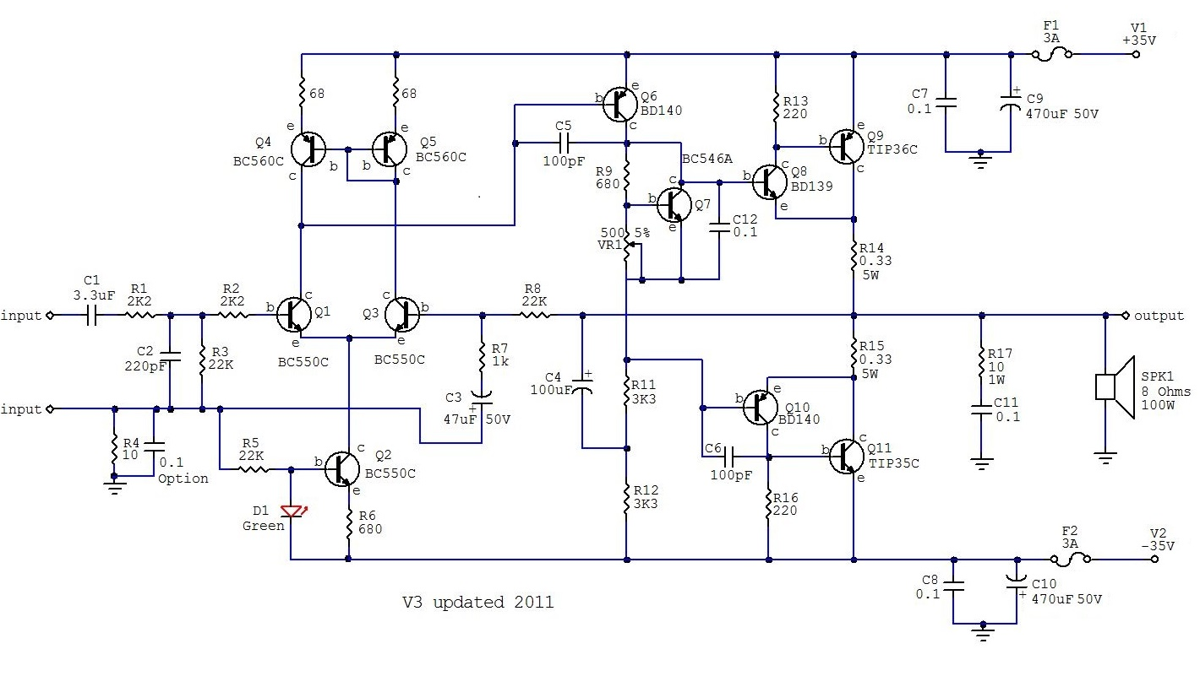
The 2024-V3.5 version comes with one heatsink for the Pre-driver and Bias Transistor, the larger capacitors, and the TIP35C and TIP36C in the TO-247 Package. The TIP’s are spaced further apart to enhance cooling under high loads. I added “beefier” capacitors in the supply (also known as the decoupling caps) around output transistor area. I found this helped the “instantaneous power output” during “transients” as the main power supply drops off under the varying load.
Making it a fairly bullet-proof output when used with power supply rails of around +/- 35Vdc.
I use the parts from my SMP supplies (manufacturing in Shenzhen) which are LOW in ESR, and 105°C rated, to give a high standard of durability and reliability.

The Updated V3.5
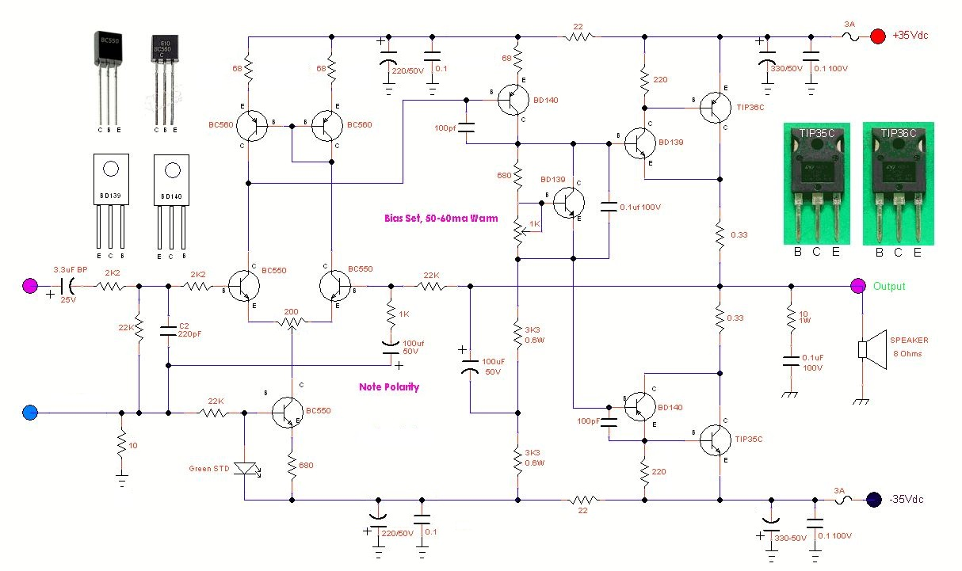After many years of listening to amps, I really liked this simple arrangement in a “Sziklai” format and prefer it over the more, popular Darlington formats.
The combination of the NPN-PNP pair and vice versa, act like a pair of single and stable High Gain Transistors.
As output transistors in amplifiers can get very hot and as heat rises, I prefer to mount “hot parts” at 90 Degrees
to the PCB.
They should not be too close to the other components, excessive PCB heating and cooling, as well as dry solder joints, can form quicker over time. This is also a balance of “how far one can keep parts away from each other for good thermal tracking, bias, stability and other noise induced issues”! They should be mounted directly to a large Heatsink with Kapton Tape and computer grade thermal paste for the best results.

This amp is designed primarily for use in “Home Hi Fi” where the average speakers used are 8 Ohms.
For its size, clarity and value, I find this is amplifier to have a ‘better’, ‘cleaner and richer sound” into an 8 Ω speaker load than loading them up with lower valued 4 Ω loads. There is not issues with driving this into 4 Ohm loads but you must reduce the supply voltages to +/- 32 Volts, and not much above this.

Note: Speakers in general, do dip into 6 ohms when in the bass regions, this is normal. The reality is that a speaker’s impedance will actually vary quite widely depending on which frequencies it is producing.
This is why speakers are rated as “nominal Impedance”.

In this amp I retained the use of 0.33 Ω resistors in the output stages. This was done to give a good balance of bias stability and feedback to the bias network. This loses a little in “total output power” but it’s not an issue. You could use 0.22 Ω or 0.1Ω degeneration resistors if you feel the need and are not going to use speakers under 4 Ohms at the voltages above +/-32V. These TIP’s will handle the higher currents very well, but they will not handle the higher voltages, especially greater than + /- 40V...

The pre-driver transistors used here are the BD139-160/BD140-160, both types of transistors are “Epitaxial” based and 160Hfe types, these types are a favourite with me. These also work very well here, but only to a max of
+/- 40VDC.

65W x 2 is very reasonable in a Home Hi-Fi amp and at +/- 35V it’s attainable.
That said, if you do require more power than this, then you need to increase the voltage and current used and it will require upgrading of all the transistors,
The transistors BC550 & BC560, will need to be changed, then the pre-drivers from BD139/BD140 to TTA004B/TTC0004B or similar, and the main drivers will need to be changed to MJL21194/ MJL21193 types, or the Newer TTA/TTC0002 Series or similar. This works well to +/- 42Vdc.
But I have another amp for this level >100W.
These changes will give you higher power and voltage ratings, but these will also add $$$ to your build.

The new version includes a 200 Ohm Trimmer in the LTP stage. This was added to be able to adjust any offset in the amp’s output. Although I never had a problem, this can happen when different transistors are use in the LTP stage.

To ensure stability with reactive loads, there is a small circuit added at the output. This circuit is called a Zobel Network. Typically, these networks basically employ a 4.7 Ω to 10 Ω/1W resistor and 100nF or 150nF-100+V capacitor, from the speaker output to the earth.

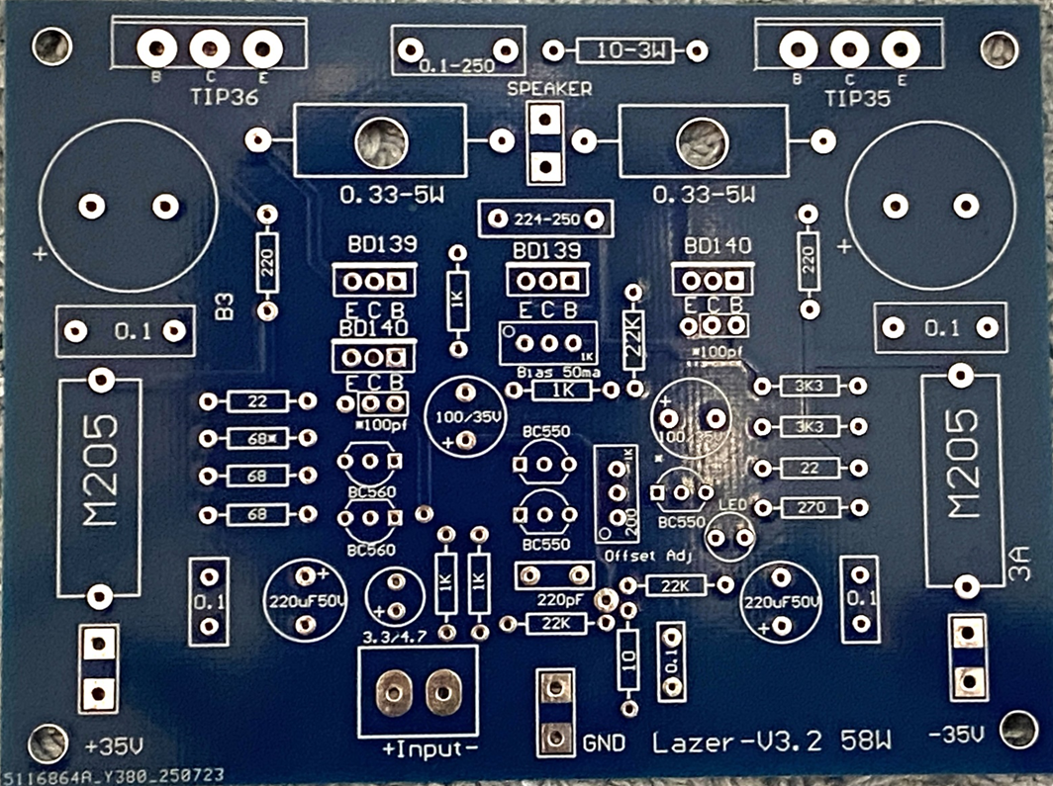

Construction:

Firstly, Inspect the PCB for any shorts or cracks that may have been missed by the test machines.
As this PCB supplied is double sided, it requires more heat to solder the pads and components.
You will need a good hot soldering iron, it needs to be 40W or more.
Wipe it often on a damp sponge or cloth, to keep it clean, then apply a little solder to the tip, to give it a wet look. This is called 'tinning' and will help to prolong the life of the tip, this also helps you to make good connections. When the solder looks dirty on the tip, it needs cleaning. Use thin resin-core solder. Do not use any flux or grease. Typical soldering is around 3 seconds on most parts, not too much longer, but also the solder should flow through pad well.
Start by installing all the small resistors then Double Check with your multimeter that the resistors you have fitted are the correct values before soldering. These are Metal Film types, and they are hard to see the colour codes. When fitting the 0.33/5-Watt power resistors. Do not fit them down all the way down on the PCB. Leave them around 2-3mm in height off and above the PCB. This will add cooling as they can get hot.
Then load the transistors (except the main outputs), capacitors, and the LED. Check the LED is installed, in place and the correct way around. The anode, long leg, sits towards the BC550.
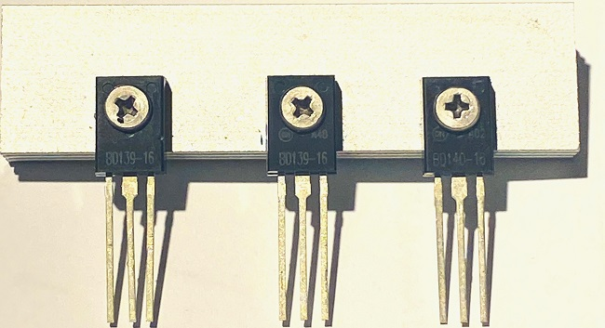
The 2 x BD139 and the BD140 Pre-drivers and Bias Transistors have a new heatsink and screws. These will sit on the Aluminium Heatsink provided. These will need half a drop thermal paste. The heatsink Length = 65.00mm
These do not sit down on the PCB. They sit just above the Cap 224-250V. This ensures a little better air flow and hence cooling.
The input capacitor (supplied) is a 3.3uF or 4.7uF bipolar type, which means it can be installed either way around, but I prefer the positive side to the input side.
Next, install the bigger capacitors. Note the 2 x 2200uF capacitors the 220uF and 100uF capacitor’s polarity.
Then, install the other parts, connectors, and terminals, fuse holders etc.

When installing the power terminals, do not hold them in your fingers when soldering, the heat from the iron will pass through quicker than you think and burn your fingers! Use strong tweezers or small pliers to hold them while soldering.

Then the two main transistors are fitted last. Use some Mica Washers between the body of the transistor and the heatsink or for a cleaner way, use Genuine Kapton Tape. Add a smear of “decent” thermal paste like the stuff used in computers, not the standard white 1960’s cheapy, and/or, DO not use the silicon pads as they are NOT very good for high power high heat transfer applications.
These will need to be aligned to your heatsink, then soldered into place.
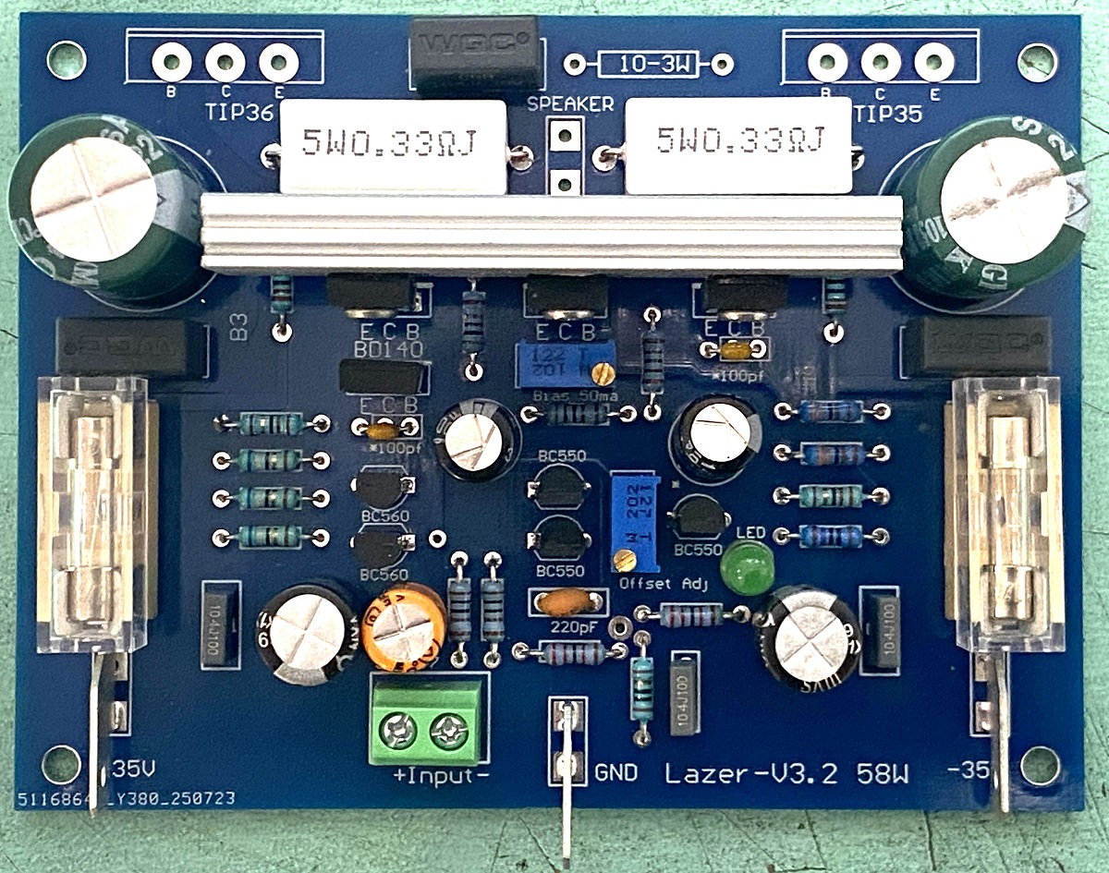
Notes:
When all is done, wash the main PCB down with FLU400 Flux Clean or similar. Use an old Tooth brush to gently clean and a hair dryer to blow out any liquid and dry off. This will give you a clean and great looking PCB and Amp board.

The amp can be run from +/- 22Vdc to +/- 36Vdc max power supplies.
To get the full 65W output, into an 8Ω Load, the transformer used must have at least 120VA rating for each Amp Module and be around 26-0-26Vac. (240VA rated if two modules ‘e.g. A Stereo Amp’).
So look around to find a suitable transformer of your choice and use. I have one of these older stereo amps still running with 2 x 24Vac/4A transformers removed from damaged Hakko soldering stations!

Testing:
Before applying any power.
The 200 Ohm Trimmer is fitted in the LTP stage, this will need to be adjusted to 99 Ohms per side, ie centred.
Then there is the Bias Trimmer VR2 this is a 1K Ohm type, make sure that this is set to minimum resistance (turn fully anticlockwise) to get the minimum quiescent current. This is very important, if it is not set to minimum resistance, the quiescent current at first power up will be very high and possibly blow your outputs!!
Check the components are in the correct positions, do not connect any input, or speakers at this time.
Make sure you have the output transistors bolted or clamped to some form of decent sized Heatsink.

As these amplifiers grow in power, certain testing ways are more important than others.
The basic way requires 3 x Multimeters, two will monitor the current flowing into the + and – Rails while the third one is watching the V offset, (this is done at the speaker terminal).
A pair of 24V 10W light globes can also be used here, these are connected in series to the “power in” terminals.
If something is wrong, then these will light up.
Connect the centre pin terminal, marked O v, to the earth point of the power supply first, then connect the +35v and the -35V to the Supply.
I used to use two 500ma panel meters which I have from my power supplies. I placed them in line (read In between) the + and – Wires from the power supply and the + and - 35V terminals on the amp.
Now days I use two x 120V 3A Power Supplies, which is expensive, but we have these in production….

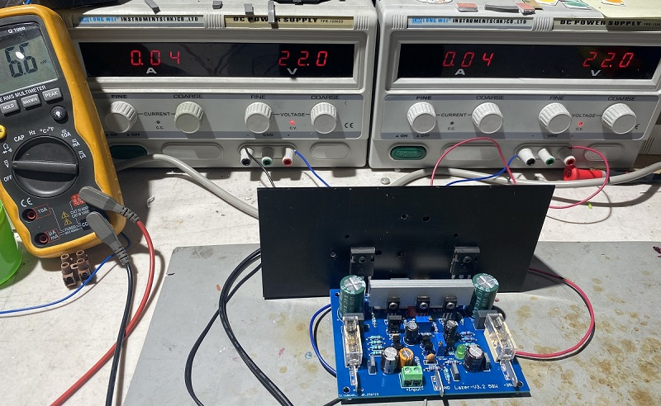
Above shows how we start, from 0V + 0V and move slowly up to the desired +/- 35V DC, note above is at +/-22V and the bias has already kicked in so it needs to be backed off until you reach the desired voltage. +/-35V is where we set them in testing. if the Bias is high or the offset is out, it can be adjusted easily and accurately.

If all is well, power up for 1 second, and observe. If the readings go above 100-500ma turn off the power immediately.
Go through all the components to see if you have made an error in the parts fitted and/or if you have shorted any tracks via soldering,
Check the bias pot is set to minimum and not maximum.
Check you have not mixed up and installed any of the transistors incorrectly or they are incorrectly orientated.

If all is OK then proceed.

Start the process again, Power up again and check the readings do not go over 0.1A at any time!
Also check if there is any device or part, is hot or heating up,

VR1 is used to adjust the offset, as you power up the amp the offset will vary but settle anywhere around +/- 26mv
Input shorted to any prevent signals. Once the bias is set it may need to be trimmed to within +/-, 10mv.
Anywhere in-side this range is very good.
VR2 is used to set the bias current, normally this will be around 35-50mA, and this takes some time for the amp to warm up and stabilise (around 20 minutes or so). So it MUST be checked and adjusted when warmed up,
You can also check the Bias current by measuring the voltage across the emitter resistors. The 0.33-Ohm resistors.
This should be around 0.014V x 0.33 Ohms, which gives you around 0.042 A or 42ma, which is perfect.
Then recheck the offset voltage at the output speaker terminal.
Do not to operate the amp under abnormal conditions, i.e. 40°+ days.

Connections:

The +ve speaker output wire is fed to the speaker from the rear terminal of the PCB,
The –ve of the speaker wire will run to a central point on the main GND Terminal located at the power supply.
Try to run your wiring in a twisted format until one of the wires needs to run off to the PCB or the Power supply.
The best way, is to run your speaker –ve’s, the amps –ve’ and the earth wires at central spot near the power supply.
This method helps to avoid “ground loops” forming and induced Hum.
The amp has a 10 Ω “lifting resistor”, so the input can run (through twisted pair or shielded cable), directly to the rear chassis. The amp may make a small thump on start, so I use the soft start circuits.

The BOM below is provided with prices in AUD and based on the use of “Decent Parts”.
These prices are given in general terms based on internet prices but can vary a lot in shopping around.
BOM | Part | Does what? | Cost
R1 | 1K Ohms-1/4 W M/F | Input Limit | $ 0.05
R2 | 1K Ohms-1/4W M/F | Input limit | $ 0.05
R3 | 22K Ohms-1/4W M/F | Input shunt | $ 0.05
R4 | 10 Ohms-1/4 W M/F | Hum & Noise Reduce | $ 0.05
R5 | 22K Ohms 1/2W M/F | Bias LED & Q2 | $ 0.05
R6 | 1K Ohms 1/2W M/F | DC Offset Q2 | $ 0.05
R7 | 1K Ohms 1/2W M/F | Feedback stability | $ 0.05
R8 | 22k Ohms 1/2W M/F | Global Feedback | $ 0.05
R9 | 1K Ohms 1/2W M/F | Bias Setting | $ 0.05
R11 & R12 | 3K3 Ohms 1W C/F | Bootstrap | $ 0.20
R13 & R16 | 220 Ohms 1W M/F | Pre-Drivers Setting | $ 0.20
R14 & R15 | 0.33 Ohm 5W Ceramic | Main Driver Emitters | $ 0.80
R17 | 10 Ohms 1W C/F | Zobel Network | $ 0.10
VR1 | 201 – 200Ohms MT | V Offset Adjust | $ 1.00
VR2 | 102-1K ohms MT | Bias Adjust | $ 1.00
C1 | 3.3uF or 4.7uF Bipolar 5mm | Input Signal | $ 0.30
C2 | 220pF 50V Ceramic 5mm | Input Filter | $ 0.10
C3 | 100μF-50V- 5mm | DC Stability & Feedback | Removed
C5 & C6 | 100pf-100V 5mm Ceramic | VAS stage stability | $ 0.10
C7, C8 | 0.1μF-250V- 10mm | Noise & Decoupling | Removed
C9, C10 | 2200μF-35V- 10mm | Line Decoupling Capacitors | $ 4.00
Q1 & Q3 | BC550C NPN Transistor | Mirror input Pair | $ 0.60
Q2 | BC550C NPN Transistor | Input Bias Mirror | $ 0.30
Q4 & Q5 | BC560C-PNP Transistor | Current sharing pair | $ 0.70
Q6 | BD140G- PNP Transistor | VAS driver | $ 1.00
Q7 | BD139G NPN Transistor | Bias Controller | $ 0.20
Q8 | BD139G-NPN Transistor | Pre driver | $ 1.00
Q9 | TIP36C-PNP Transistor | Output driver | $ 3.50
Q10 | BD140G-PNP Transistor | Pre driver | $ 1.00
Q11 | TIP35C-NPN Transistor | Output driver | $ 3.50
Con 1 | 2P 5.08mm 2 Pin PCB | Screw Terminal Block | $ 0.30
Con 2 | 3P 5.08mm 2 Pin PCB | Screw Terminal Block | $ 0.40
Con 3 | 2P 5.08mm 2 Pin PCB | Screw Terminal Block | $ 0.30
Fuse & Holder | M205 Fuse Holder and Fuses | M205 3A Fuse | $ 3.00
PCB | Lazer 60W-3.5V Amp | PCB | $ 5.50

Removed parts are supplied free when you buy the amp kit from us, these are brand new parts but removed from production.
To keep the amplifier stable and operational over many years, I have tried to get all these main components from one manufacturer.
In this case On Semi. While I cannot guarantee the supply of parts at a later stage should these become EOL.

Updated + Spelling 12/11/2024

