Capacitors are widely used in electronic circuits for blocking direct current (DC) while allowing alternating current (AC) to pass.
They are also used in filtering out the various frequencies as well.
In resonant circuits they are used to tune radios to particular frequencies.
In analog filter networks, they help to smooth the ripple output of a power supply.
In electric power transmission systems they stabilize voltage and power flow.

The main types are ceramic and electrolytic capacitors. The difference between them is:

A ceramic capacitor is a type of capacitor whose dielectric is a ceramic material. In the simplest construction of these, a layer of a ceramic material sits between two conductive plates. However, the most frequently-used type of ceramic capacitors is the so-called multi-layer chip capacitors (MLCC). In MLCCs, there is a number of conductive plates and a ceramic material is sandwiched between each pair of plates. Effectively, they work as though they are many small capacitors in parallel, which gives a large combined capacitance.

An electrolytic capacitor is a type of capacitor that uses an electrolyte in order to increase its capacitance. Typically aluminium, tantalum, or niobium acts as the conductive material. The dielectric in these capacitors is the oxide layer that forms on these metals used in their construction. In the space between the conductors, there are papers which are soaked in an electrolyte. The electrolyte itself acts as the anode while one of the metal plates acts as the cathode. This form of manufacture can make the capacitance of the capacitor very high.

This gives them the differences for their intended uses.
Ceramics are used more for either filtering out high frequencies or shunting high frequencies to protect IC’s from line noises, or for filtering frequencies in audio gear,
Whereas Electrolytic’s can filter out lower frequencies or provide larger amounts of stored energy for use in power supplies and timing applications.

That is why you see the ceramics in pf’s over Electrolytic’s in uF’s
Ceramic and Electrolytic capacitors are only two types of capacitors used in electronic circuits shown here.

Capacitors are a serious study of components that come in many types, shapes, forms and functions.
They are each made and sold to be used within a given set of specifications.
Then there are many variations to the actual “capacitance value” when in use.
For most of them, there is a common rule of thumb that capacitors have their voltage rating, be de-rated by at least 25% from their actual ratings, as standard.

Firstly, there is the basic way to identify the value of capacitance, then, there is the selection of voltage to chose for use of that capacitance. So what do the letters mean on a capacitor?

The capacitor colour code system is not presently in use. It was employed a long time ago on unpolarised polyester and mica moulded capacitors. But there are still many old capacitors around which are why the colour code system is still necessary.
Nowadays, capacitors such as disk and film types conform to the BS1852 standard and its new replacement, BS EN 60062

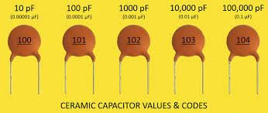

.
The colour system has been replaced by a latter or number-coded system, as below.

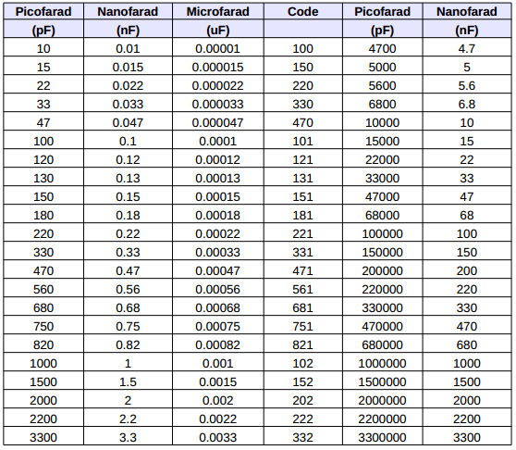

And then there is a basic chart of “Tolerance” to use below, it does start at 0.1% but these are not
In general circulation.

Code on the Capacitor Tolerance Value

  E | ±0.5%
  ±0.5% | ±0.5%
F | ±1%
G | ±2%
H | ±3%
J | ±5 %
K | ±10%
L | ±15%
M | ±20%

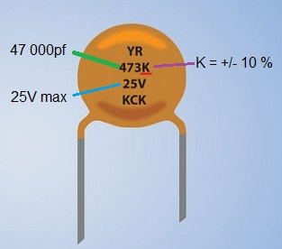

Above is a good example of the ceramic capacitors and their coded tolerances C0G to Y5V over temperature.
If you are going to design and or build audio devices or if you simply prefer higher accuracy in your timing circuits then you have to choose C0G over X7R or X5R:

Variations over Temperature:
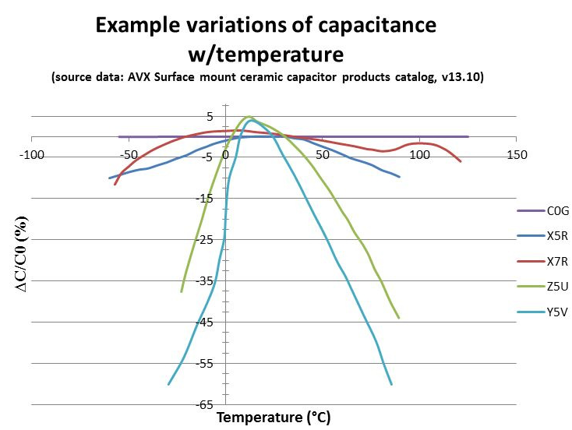
That’s an issue that many of us overlook, we forget to check this section of data and we assume that they are within a reasonable “spec”, not to change over temperature.
We tend to look at the operating temperatures of the products but not at its de-rating curves as shown below, after all we don’t think they will “drift” to a 70% value!
SMD is also another challenge on top, the size of the parts also determines its change in Capacity / Voltage!

Electrolytic and Tantalum capacitors often have the capacitance (in uF) and their maximum allowed voltage, printed on them in a readable form.
The capacitance will usually be followed by the letters "uF" to indicate measurement in microfarads, but the voltage may or may not be followed by a V.

“Depending on the dielectric formulation, these capacitors can lose more than 70% of its rated capacitance with an applied voltage!

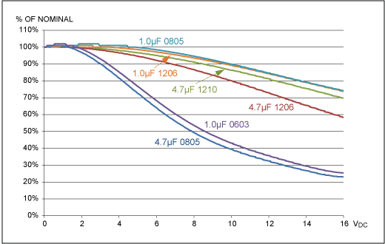

Take a good look at a typical 4.7uF 805 capacitor then look at the difference in the same value 4.7uf in a 1206 chip cap at a higher voltage …..Size here does make a difference and as products are made smaller and smaller for consumers and industry demands, these changes can become serious issues in the functions of the product made.

My products are derived from circuits and production made over many years,
There were and are many items made from audio amplifiers to alarms to switch mode power supplies.
SMPS are made to be SAA approved so the level of quality and componentry is and must be and is high.
There are many parts now on the market that do not met the criteria so they are sold off through various sites. Just remember this when buying,.

Learning about Capacitors takes time what they actually do and where they are used best is a challenge.

Spelling, 8/2020

