555 Timer Circuits

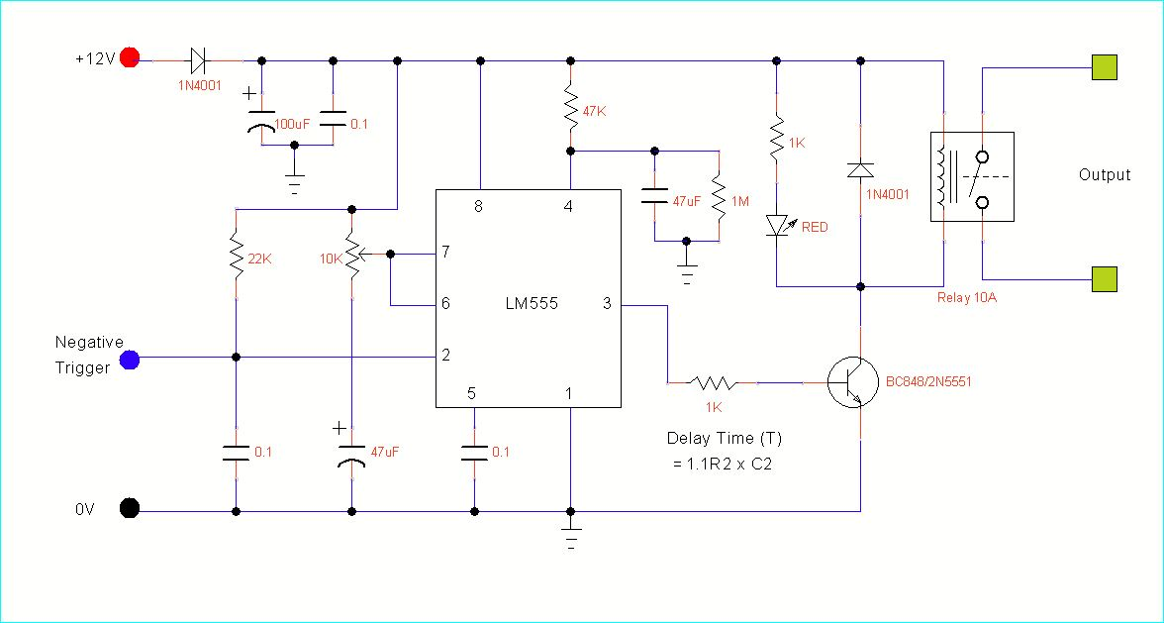

This is the circuit in the Photo and the basic kit

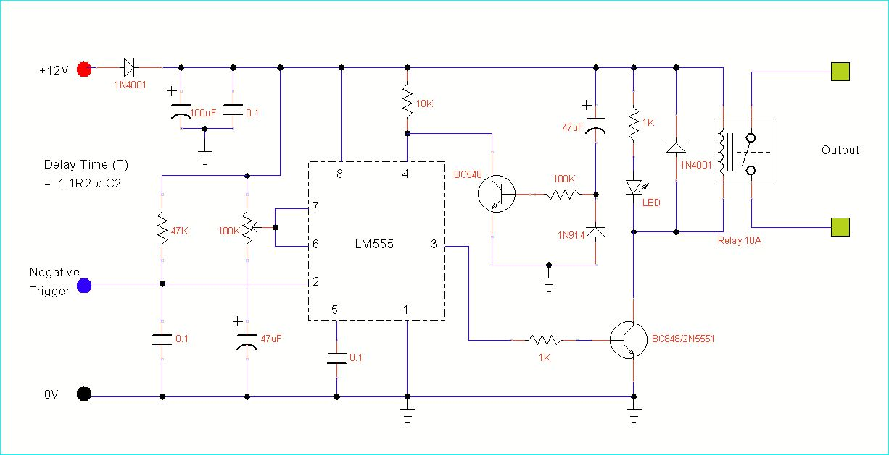

This circuit is optional. It gives you a longer delay at start up , so you can use sensors that require time off at start up

