Through-hole package

1N914 & 1N4148 in DO-35 glass axial package. 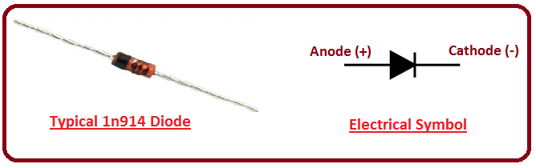

Surface-mount packages

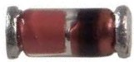 LL914 & LL4148 in MiniMELF package.

1N4148W in SOD-123 package. 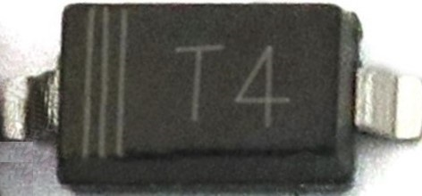
Note: Some 1N4148 family surface-mount packages are marked with "T4" text.

Specifications

Absolute maximum ratings (stress ratings, consult datasheet for recommended ratings).
V_{RRM} = 100 V (maximum repetitive reverse voltage)
I_{O} = 200 mA (average rectified forward current)
I_{F} = 300 mA (DC forward current)
I_{f} = 400 mA (recurring peak forward current)
I_{FSM} = 1 A at 1 s pulse width; 4 A at 1 μs pulse width (non-repetitive peak forward surge current)

Electrical and Thermal characteristics:
V_{F} = 1 V at 10 mA (maximum forward voltage)

V_{R} = 75 V at 5 μA; 100 V at 100 μA (minimum breakdown voltage and reverse leakage current)

t_{rr} = 4 ns (maximum reverse-recovery time)

P_{D} = 500 mW (maximum power dissipation

